REPORT ON SSIP AWARENESS PROGRAM
Government Science College, Chhota Udepur

1. Event Summary
- Event Name: Student Startup and Innovation Policy (SSIP 2.0) Awareness Session
- Date: December 8, 2025
- Time: 12:00 PM
- Venue: Government Science College, Chhota Udepur
- Host: Dr. Nupoor Prasad
- Total Participants: 23 students from FY, SY, and TY

2. Introduction
A specialized awareness program regarding the Student Startup and Innovation Policy (SSIP) was organized at Government Science College, Chhota Udepur, on December 8, 2025. The session aimed to enlighten students about the entrepreneurial opportunities and financial support systems provided by the Government of Gujarat to foster innovation at the college level.

3. Detailed Information on SSIP
During the session, Dr. Nupoor Prasad provided an in-depth explanation of the SSIP framework. The following key components were elaborated upon:
- Policy Objective: The policy is designed to identify and support student-led innovations and help them transition into commercially viable startups.
- The Support System: The program outlined a four-stage support model:
  - Exposure/Culture: Creating awareness and an innovation-friendly mindset among students.
  - Innovation: Providing resources for research and development.
  - Startup: Assisting with the formalization of business ideas.
  - Scale-Up: Supporting the growth and expansion of successful student ventures.
- Financial Assistance: Students were briefed on the availability of grants for building Proof of Concepts (PoC), filing patents, and developing prototypes.

4. Program Highlights
The program saw active participation from 23 students across the First, Second, and Third years of the science stream. Dr. Prasad utilized visual presentations to demonstrate how the SSIP 2.0 policy acts as a bridge between academic projects and professional entrepreneurship. The students engaged in a Q&A session to clarify the application process and eligibility criteria for funding.

5. Conclusion
The session concluded with a motivating note, encouraging students to think beyond traditional job seeking and embrace the role of "job creators." The event was a significant step toward building a robust startup ecosystem within the college.

6. Event Photographs
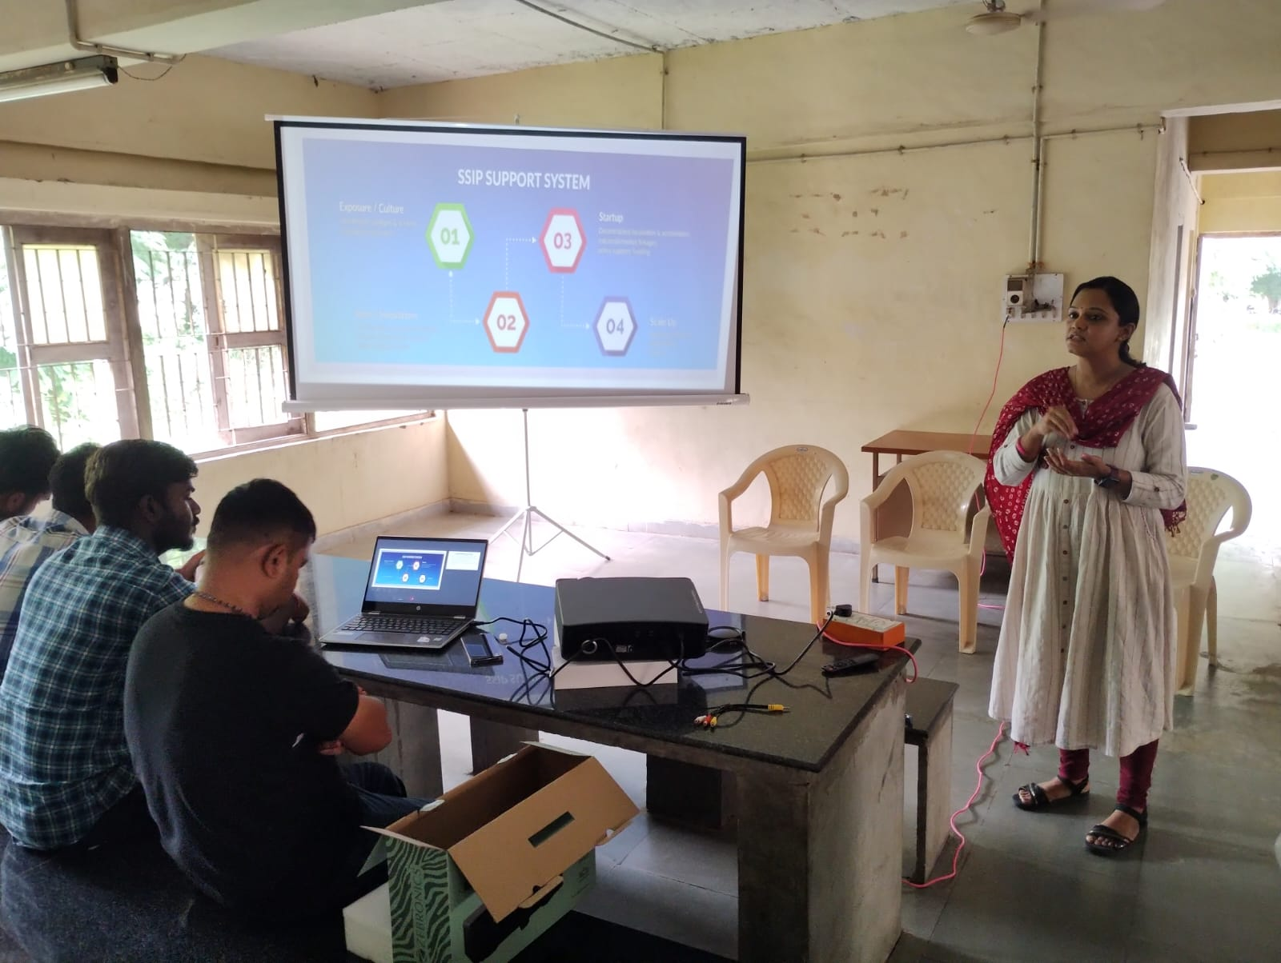
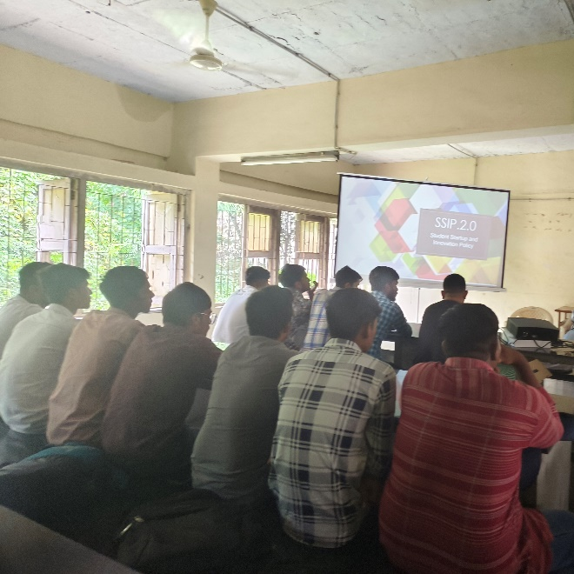

Dr. Nupoor S Prasad  SSIP Coordinator | Principal,  Government Science College, Chhotaudepur

