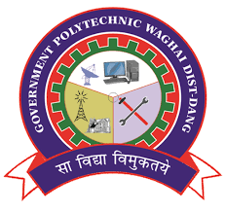 | Government Polytechnic, Waghai  Computer Engineering Department  Event Report – 2024 - 25
Event Name | One Day Workshop on IoT Technology
Event Type | Workshop
Event Location | Computer Class Room – CE - 6
Event Date | 25 April, 2025
Beneficiaries | Students
Semester | Semester 6
Total Students | 35 Students
Resource Person  Name  / Domain  / Designation | Mr. Purvaj Vaidya, Assistant Professor, IT Department, RNGPIT, Bardoli.
Event Objective | To spread awareness about IoT technology among students and bridging gap related to recent advancements in computerengineering industries.
Event Description | Mr. Purvaj Vaidya, delivered one day workshop at Government Polytechnic, Waghaion IoT technology for final year year students.  Mr. Purvaj Vaidya covers topics required for configuring IoT devices, IoT components, Software to be managed for using IoT, importance of IoT and recent trends in IoT technology.  From this workshop students became aware about basics of IoT terminology, Identifying the IoT components and analyzing IoT components for application.  Also they came to know about what to do to develop small IoT applications using Hardware devices with the help of IoT.  So once again G P Waghai is thankful to sir for sharing valuable knowledge and all staff who supported for this motivational workshop.
Event Outcomes | 1) Students learnt process of using IoT devices.  2) Students learnt about identifying different IoT components.  3) Students learnt process of developing IoT application.  4) Students learn to configure IoT devices to develop small applications.
Related POs and PSOs | PO2,PO3,PO4,PO7,PSO1
Event Photographs - One Day Workshop on IoT Technology - 25 April, 2025
