WORKSHOP REPORT
 | 

An awareness seminar on 'SSIP 2.0' for first year students was conducted under SSIP 2.0 at Shantilal Shah Engineering College, Bhavnagar on 2nd February 2026. The seminar was delivered by Prof. N. P. Soni. The session focused on creating awareness among first year students regarding the Student Startup and Innovation Policy (SSIP 2.0), its benefits, innovation opportunities, startup support, funding assistance, and the importance of entrepreneurial thinking.
A total of 150 students actively participated in the event. The seminar encouraged students to explore innovative ideas and understand the various opportunities available under SSIP 2.0.
Event Details
Particular | Details
Event Name | SSIP 2.0 Awareness Seminar for First Year Students
Organized Under | SSIP 2.0
Venue | Shantilal Shah Engineering College, Bhavnagar
Date | 2 February 2026
Speaker | Prof. N. P. Soni
Total Participation | 150 Students

Event Photographs
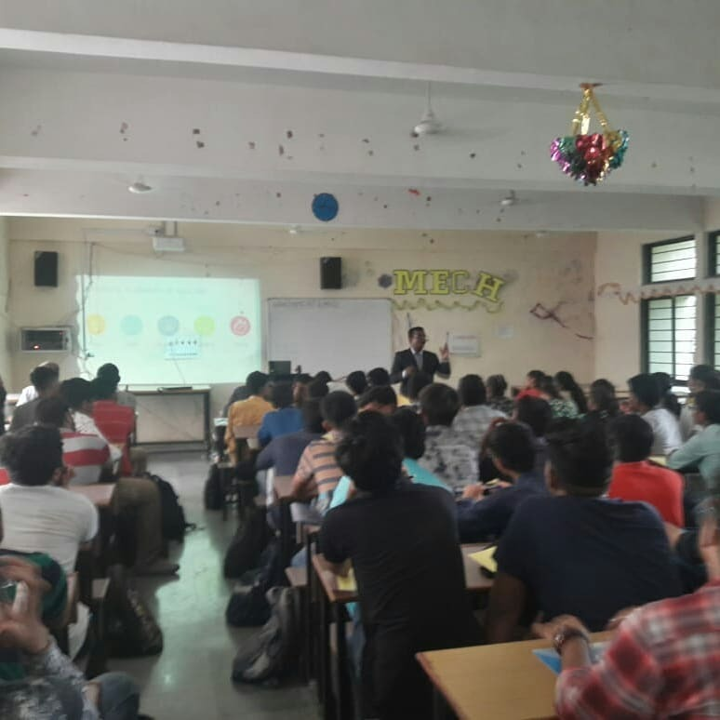
Seminar session conducted for students under SSIP 2.0.
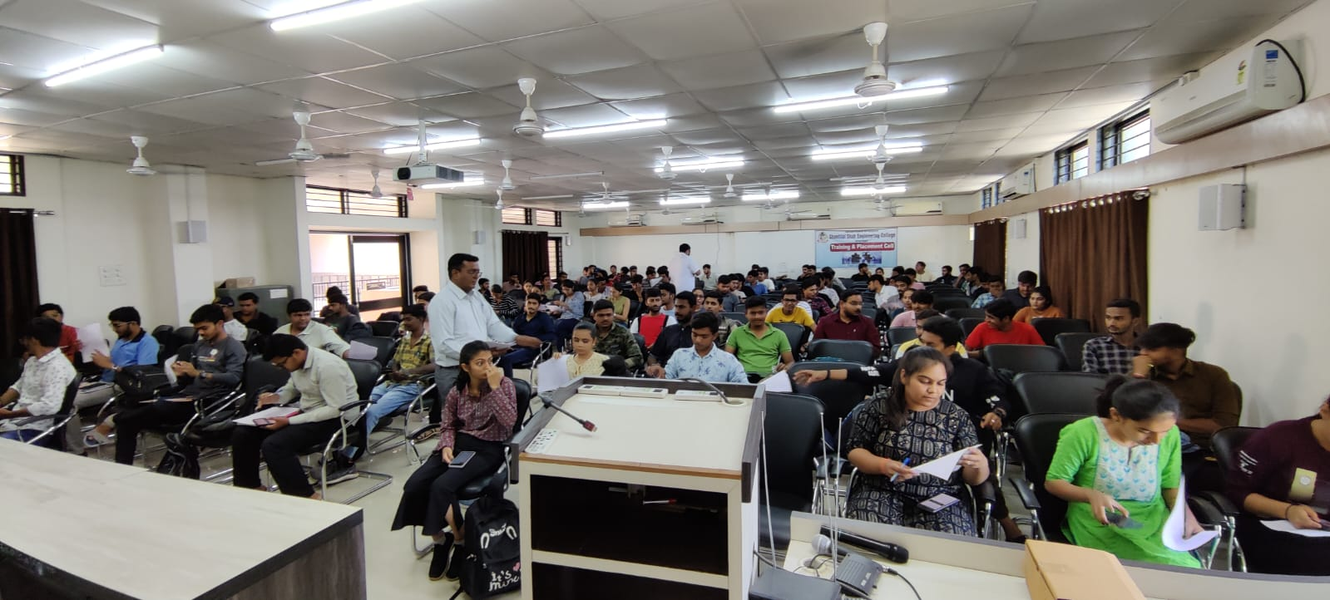
Students participating in the awareness seminar.
The seminar successfully introduced first year students to the vision and opportunities of SSIP 2.0, motivating them towards innovation, creativity, and startup culture.

